Editable Annex
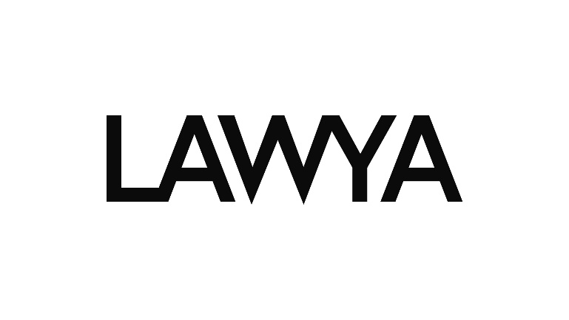
Training of Academic Staff

general information
Public contract identification: | Training of Academic Staff
Public contract type: | Service
Public contract regime: | Above-threshold public contract
Procurement procedure type: | Negotiated procedure without prior publication
Contracting Authority: | Slezská univerzita v Opavě / Silesian University in Opava
Address of the CA: | Na Rybníčku 626/1, 746 01 Opava
ID No.: | 47813059
Legal form of the CA: | 331 – Funded organisation
Represented by: | doc. Mgr. Tomáš Gongol, Ph.D., rector
Address of the CA profile: | https://zakazky.slu.cz
Project identification: | Development of Competencies for a Sustainable Future at the Silesian University in Opava – Rozvoj kompetencí pro udržitelnou budoucnost na Slezské univerzitě v Opavě
Project number: | NPO_SU_MSMT-2122/2024-5
(“Public contract“, “Contracting Authority”, “Project”)

general information on the supplier
Supplier identification: | [to be completed by Supplier]
Registered Office: | [to be completed by Supplier]
ID No.: | [to be completed by Supplier]
VAT No.: | [to be completed by Supplier]
Commercial Registry No.: | [to be completed by Supplier (if relevant)]
Authorised representative: | [to be completed by Supplier]
Phone No.: | [to be completed by Supplier]
E-mail address: | [to be completed by Supplier]
Website: | [to be completed by Supplier]
Contact person – name: | [to be completed by Supplier]
Contact person – phone: | [to be completed by Supplier]
Contact person – e-mail address: | [to be completed by Supplier]
The Supplier is a Small or a Medium Entity: | YES / NO
The Supplier is registered in The Register of Beneficial Owners: | YES / NO
(„the Supplier“)

BASIC QUALIFICATION – SWORN STATEMENT
  - Supplier, to be completed by Supplier, registered office: to be completed by Supplier, ID no.: to be completed by Supplier, („Supplier“), hereby declares that it meets the basic qualification requirements set forth by Act No. 134/2016 Coll., on Public Procurement, as amended (the „Act“) in the following scope, namely that it is a participant who
    - has no outstanding tax arrears related to excise duties recorded in the tax records in the Czech Republic or in the country of its registered office,
    - has no outstanding arrears in insurance premiums or penalties for public health insurance in the Czech Republic or in the country of its registered office,
    - if the Supplier is not registered in the commercial register, is not in bankruptcy, a bankruptcy decision has not been issued against the Supplier, the Supplier has not entered into compulsory administration pursuant to another legal regulation or is not in a similar situation under the legal system of its country of registered office.
  - Supplier acknowledges, that they are obligated to provide all documents of eligibility stated in article 7 of the Invitation to Tender, or more precisely in the Act, if they are called upon to do so by the CA in accordance with Section 46 (1) of the Act. The certificates of qualification shall be shown before the conclusion of the contract.
  - Supplier acknowledges, that the documents demonstrating basic qualification shall demonstrate the compliance with the required eligibility criterion no later than 3 months prior to the date of the submission of a bid.

Other declarations
  - Supplier hereby declares that he has acquainted himself with all conditions of the public contract, particularly with the subject matter of the public contract, qualification requirements and payment and commercial conditions, and has comprehended them.
  - Supplier hereby declares, that should they be called upon to conclude the contract, they will provide the Contracting Authority with all necessary cooperation
  - Supplier hereby declares that all information contained in the tender is truthful and should such a need arise, the Supplier shall provide the CA with all necessary cooperation in order to verify it with third parties.
  - Supplier acknowledges that the CA will ascertain information pertaining to the beneficial owners of the selected Supplier in accordance with the relevant legislature.
Supplier acknowledges that the selected Supplier, should they be an alien legal person, shall be called upon in accordance with Section 122 (3) of the Act, to procure an extract from a register analogous to the Register of Beneficial Owners. In the case that such register does not exist, the selected Supplier will be called upon to,
- disclose identifiers pertaining to all persons who are his beneficial owners and
- disclose documents which show relations between all the above mentioned persons and the Supplier; such documents are:
      - an extract from the Commercial Register or any other similar records,
      - a list of the Supplier’s shareholders,
      - decisions by the Supplier’s statutory body on profit allocation,
      - memorandum of association or articles of association (by-laws).
  - Supplier hereby declares, that should they be called upon to do so, they will provide the Contracting Authority or any relevant regulatory body with all necessary cooperation with executing a financial audit in accordance with Section 2 (e) of Act No. 320/2001 Coll., on Financial Control.
  - Supplier hereby declares to meet the conditions of Section 4b of Act No. 159/2006 Coll., on Conflict of Interest, as amended, ("CCI"), i.e. that for a Supplier who is a commercial company, as well as for subcontractors who are commercial companies through which the participant in the procurement procedure demonstrates qualification, it applies that in none of them does a public official referred to in Section 2 (1) (c) of the CCI, or a person controlled by them, own a share representing at least 25% of the shareholder's participation in the commercial company.
  - Supplier hereby declares that they do not fulfil the conditions of the prohibition of awarding a public contract within the meaning of Section 48a of the Act, i.e. that the Supplier, as well as its subcontractors, are not subject to international sanctions pursuant to the Act regulating the implementation of international sanctions.
    - Supplier hereby declares that, in the event of concluding a contract with the Contracting Authority, the payments provided by the Contracting Authority in connection with the implementation of the public procurement contract shall not be made available, directly or indirectly, not even in part, to or for the benefit of natural or legal persons, entities or bodies subjected to so-called individual financial sanctions according to the Council Regulation (EU) No. 208/2014 of 5 March 2014 concerning restrictive measures directed against certain persons, entities and bodies in view of the situation in Ukraine, Council Regulation (EU) No. 269/2014 of 17 March 2014 concerning restrictive measures in view of activities that undermine or threaten the territorial integrity, sovereignty and independence of Ukraine and Council Regulation (EC) No 765/2006 of 18 May 2006 concerning restrictive measures against President Lukashenko and certain officials of Belarus, regardless of whether they are persons with direct or indirect links to a Supplier or a subcontractor of a Supplier.
  - Supplier hereby declares that the conditions set out in Council Regulation (EU) No 833/2014 of 31 July 2014 concerning restrictive measures in view of Russia's actions destabilising the situation in Ukraine Council Regulation (EU) No 2022/576 of 8 April 2022 amending Regulation (EU) No 833/2014 concerning restrictive measures in view of Russia’s actions destabilising the situation in Ukraine are not fulfilled, i.e. that the Supplier is not:
  - a Russian national, natural or legal person established in Russia,
  - a legal person, entity or body whose proprietary rights are directly or indirectly owned by more than 50 % by an entity referred to in point (a) of this paragraph; or
  - a natural or legal person, entity or body acting on behalf or at the direction of an entity referred to in point (a) or (b) of this paragraph.
The above applies in the case of a joint tender for each of the connected suppliers, including, where they account for more than 10 % of the contract value, subcontractors, suppliers or entities whose capacities are being relied on within the meaning of the public procurement Directives (according to the amount of the bidding price in CZK excluding VAT).
  - Supplier hereby declares that neither the Supplier nor any employee or member of their statutory body, statutory authority or person otherwise close to it:
- has not participated in the preparation or award of the public contract,
- had influence or could affect the outcome of the procurement procedure,
- is in an employment or similar relationship in relation to the Contracting Authority,
either individually or in conjunction with another (sub)supplier.
Should any of the above not apply, the Supplier shall include a list of all persons who should fulfil any of the conditions as stated above along with any relevant information pertaining to the matter. This list shall be included in the tender provided by the Supplier.
  - Supplier hereby declares that all declarations and acknowledgements stated in the Editable Annex were done of their earnest and free will, free of error. This Supplier hereby declares to be aware of any and all consequences which may arrise should the Supplier provide inaccurate or false information.
In __________ on __. __. 2024
______________________
Supplier

